Module 7 Critical Thinking 4

Alex Zelmanowicz

Colorado State University Global

Professor Farr

CSC 500

31 March 2024

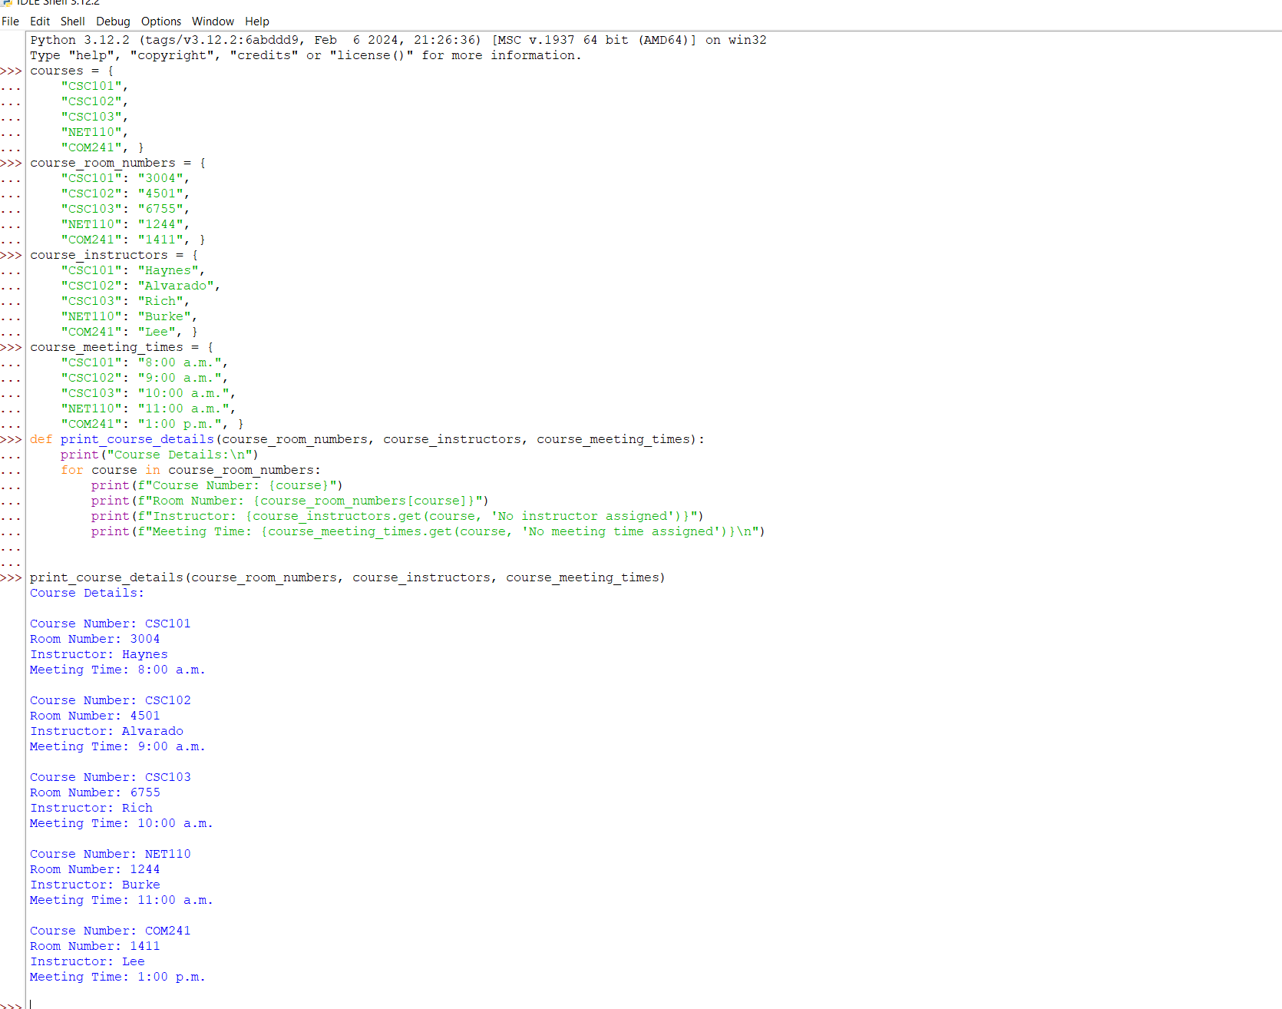

**Pseudo Code:**

**1.** Start.

**2.** Create a list named “courses” indicating every course.

**3.** Create a dictionary named “course_room_numbers” indicating which room number the course will be in.

**4.** Create a dictionary named “course_meeting_times” indicating the time that course, room number and instructor will teach at.

**5.** Create a dictionary named “course_instructors” indicating which instructor will teach the room number and course.

**6.** Make a procedure of course details so that it will print out the course, room number, time and instructor.

**7. P**rint out the procedure to get the list.

**8.** End.

**Source Code:**

>>> courses = {

... "CSC101",

... "CSC102",

... "CSC103",

... "NET110",

... "COM241", }

>>> course_room_numbers = {

... "CSC101": "3004",

... "CSC102": "4501",

... "CSC103": "6755",

... "NET110": "1244",

... "COM241": "1411", }

>>> course_instructors = {

... "CSC101": "Haynes",

... "CSC102": "Alvarado",

... "CSC103": "Rich",

... "NET110": "Burke",

... "COM241": "Lee", }

>>> course_meeting_times = {

... "CSC101": "8:00 a.m.",

... "CSC102": "9:00 a.m.",

... "CSC103": "10:00 a.m.",

... "NET110": "11:00 a.m.",

... "COM241": "1:00 p.m.", }

>>> def print_course_details(course_room_numbers, course_instructors, course_meeting_times):

... print("Course Details:\n")

... for course in course_room_numbers:

... print(f"Course Number: {course}")

... print(f"Room Number: {course_room_numbers[course]}")

... print(f"Instructor: {course_instructors.get(course, 'No instructor assigned')}")

... print(f"Meeting Time: {course_meeting_times.get(course, 'No meeting time assigned')}\n")

...

...

>>> print_course_details(course_room_numbers, course_instructors, course_meeting_times)

Course Details:

**Git Repository**: https://github.com/AlexCSUGlobal/CSC500